Q1. 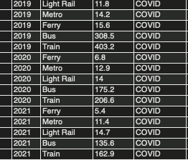

Q2. 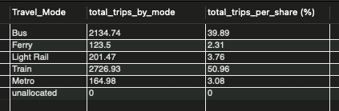

Total number of holiday per month
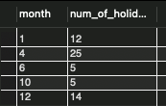

Q3: 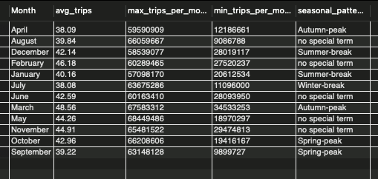

Q4: 

Q7: 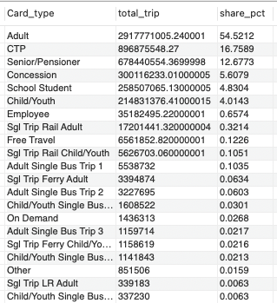
Top card type used most: Adult, CTP, Senior/ Pensioner, Concession, School student,…

